Farming Vendor Mini World
Documentation of System Design Process
Research and Requirement Gathering
To design a realistic system, I conducted informal research on how farmer’s markets operate. This included:
- Reviewing online articles describing vendor operations
- Examining sample vendor registration forms
- Observing how products are categorized and priced
- Studying how small markets track customers and sales
This research helped identify the essential data elements and interactions that needed to be represented in the database.
Identifying Core Entities
Based on the research, the following entities were identified:
- Farmer
- Product
- Customer
- Transaction
- Transaction Item
Each entity represents a real-world object or action that must be tracked in the system.
Determining Relationships
The relationships between entities were identified as follows:
- A customer can make many transactions
- A transaction can contain many transaction items
- A product can appear in many transaction items
- A farmer can appear in many transaction items
These relationships reflect the real-world workflow of a farmer’s market.
Assumptions
To keep the system manageable, the following assumptions were made:
- Customers do not require accounts; basic contact information is sufficient
- Farmers set their own prices, but the price at the time of sale is stored separately
- Products are not permanently tied to a single farmer
- Inventory tracking is not included
- Market events or schedules are not modeled
ER Diagram Development
Two ER diagrams were created:
Chen ER Diagram
- Drawn by hand
- Represents entities, attributes, and relationships
- Serves as the conceptual model
UML ER Diagram by MySQL Workbench
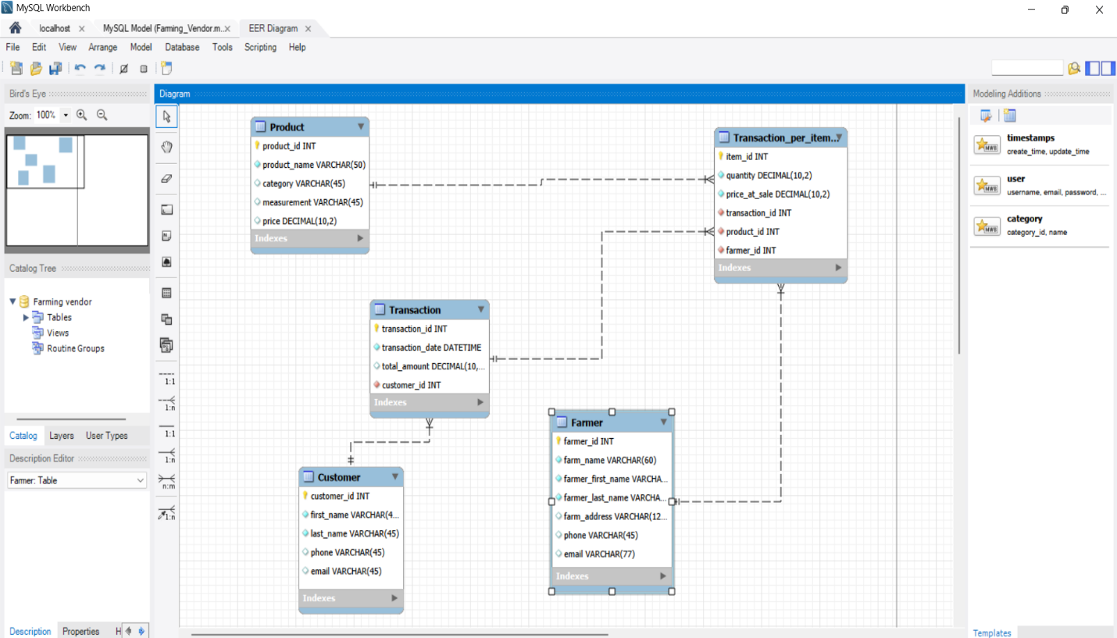

CHEN
